YEAR 11 PHYSICS 2A2B

ASSIGNMENT 5: ELECTRICITY

NAME: TOTAL: 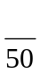
1. Draw the electric field associated with the following charged objects.
(4)

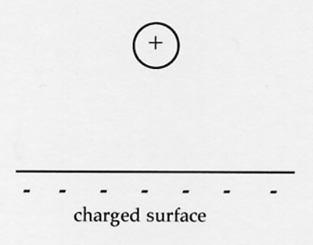
(a) (b)
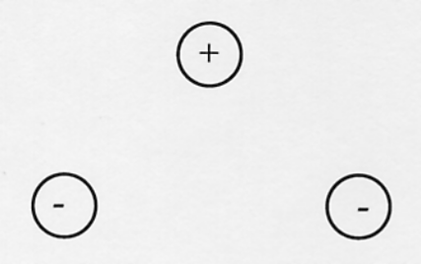

2. (a) Explain why a plastic ruler that has been rubbed on a woollen jumper can attract small pieces of paper. A diagram may help your explanation.
(3)

(b) Why does this not work very well if the air has high humidity?
(2)

3. Three isolated point charges are arranged in a vacuum as shown below. At the instant shown, calculate the resultant force on charge C due to the presence of the other two charges.
(6)
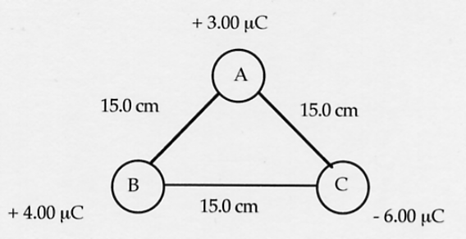
(HINT: Draw a clear vector diagram to help.)

4. A wire-wound resistor of nichrome wire is designed to operate with a resistance of 2.50 x 10³ Ω. If it has a diameter of 0.100 mm, calculate the length of wire required. (ρ_{nichrome} = 1.00 x 10⁻⁶ Ωm)
(5)

5. A compound circuit is set up as follows. The current through the 18.0 Ω resistor is 0.50 A.
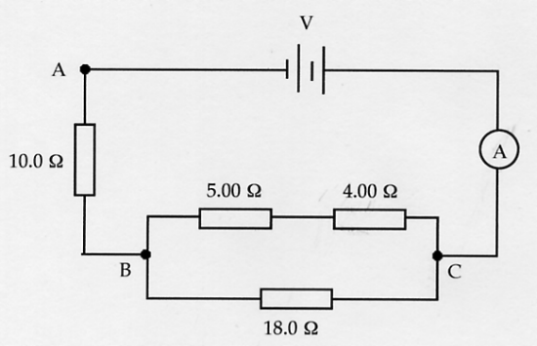

(a) Calculate the potential drop across the 18.0 Ω resistor.
(2)

(b) What current is measured on the ammeter?
(3)

(c) Determine the potential difference across the electricity source.
(4)

(d) What power is consumed within this circuit?
(3)

6. Explain why an earth leakage device (ELD) or a residual current device (RCD) is far more effective than wire fuses in protecting humans from electric shocks in the household. Describe how each device works and how they may protect us.
(5)

7. What is the cost of running a 5.50 x 10² W refrigerator for a year if it operates for 8.20 hours per day, and electricity costs 23.5 cents per unit?
(4)

8. At a Science show, a large sphere carrying a charge of - 3.60 μC is placed at the base of a vertical tube in an "electrostatics experiment". A small 2.31 g sphere with a charge of - 1.00 μC is dropped into the vertical column and is repelled by the large sphere so that it floats above it. Assume no charge is "lost' to the tube.
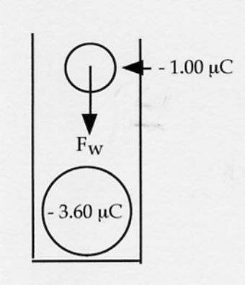

(a) What is the force of gravity on the small sphere?
(2)

(b) Use your answer to part (a) to calculate the distance between the two spheres when the small sphere stopped moving.
(4)

(c) Calculate the number of excess electrons on the small sphere.
(3)

